**Great Indian Bustard Project**

* The great Indian bustard (**Ardeotis nigriceps**) or Indian bustard is a bustard found on the Indian subcontinent.
* A large bird with a horizontal body and long bare legs, giving it an **ostrich like appearance.**
* This bird is among the heaviest of the flying birds.

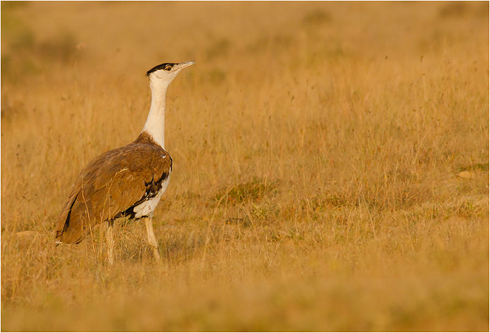

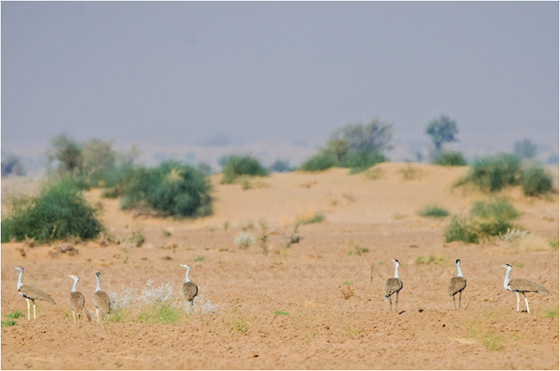

* GIB is a primarily terrestrial birds with adult males as tall as 122 cm and weigh 11-15 kg and adult females reach up to 92 cm and weigh 4-7 kg,
* GIB lays one egg every 1-2 years and the success rate of these eggs is 60-70 per cent.
* However, this rate has been reduced to 40-50 per cent due to predators like fox and dogs.

**Rapid decline**

* Till 1980s, about 1,500-2,000 Great Indian Bustards were spread throughout the western half of India, spanning eleven states.
* However, with rampant hunting and declining grasslands, their population dwindled.
* 2011- IUCN Critically endangered list
* As per a report by the Wildlife Institute of India (WII) only 150 GIBs are left in India, out of which around 90 per cent are found in Rajasthan and Gujarat.
* The GIBs are dying at the rate of 15 per cent annually due to collision with high voltage power lines .

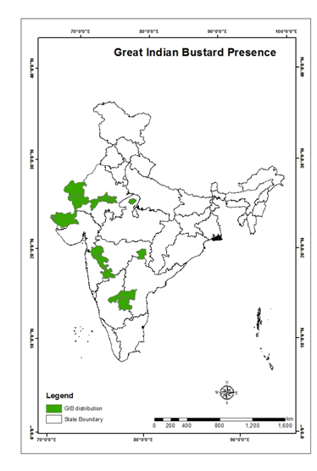

* GIB was a challenge for hunters , who had to stalk carefully to get within range
* The invention of the **Jeep** changed the method of hunting and it became extremely easy for hunters to chase bustards down in their open semi-desert habitats

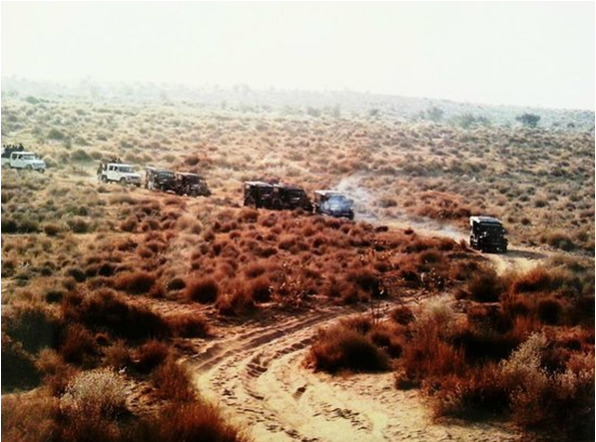

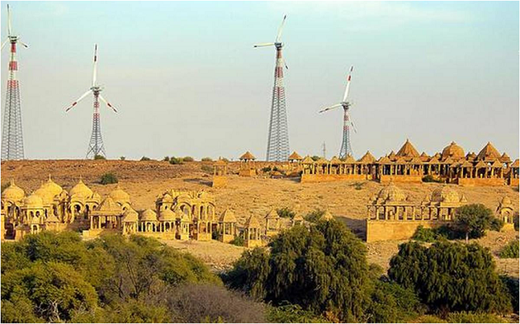

* GIB habitats have a high density of transmission lines because of the impetus on renewable energy production in Rajasthan and Gujarat.

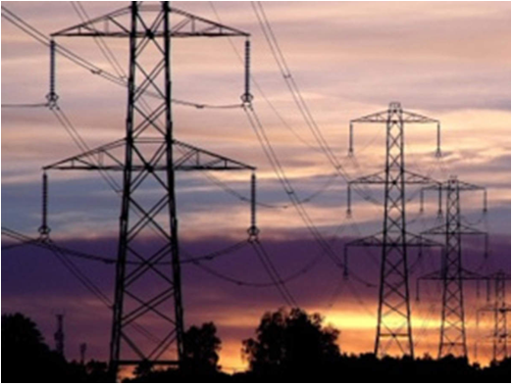

* Habitats of critically endangered Great Indian Bustard to be declared conservation reserves
* Seeking to protect the critically endangered Great Indian Bustard, the Union Environment ministry has

1. decided to declare their habitats as conservation reserves and
2. asked power companies to consider placing high voltage lines under the ground as the birds have died after coming in contact with them.

* **Conservation reserves and community reserves**are terms denoting **protected areas**  which typically act as **buffer zones** to or **connectors and migration corridors** between established national parks, wildlife sanctuaries and reserved and protected forests .
* **Community reserves** – On land of private or community ownership, if a group of people are doing conservation work and Government gives it a legal recognition
* **Conservation reserves** – are government owned land.
* In both the cases conservation efforts are by local community only.
* Mortality of adult GIBs is high due to collision with power lines that criss-cross their flying path.
* WII’s research has shown that power lines, particularly high voltage (33-440 KV) transmission lines are the biggest threat to GIB.
* All bustards are prone to collision due to their **poor frontal vision** and **inability to see the power lines from a distance.**

**Conservation efforts by Min. of Environment**

* Species Recovery Programme
* Habitat Improvement and Conservation Breeding of Great Indian Bustard-An Integrated Approach
* Rs 33 crore for the conservation of the GIB through this project
* For conservation, breeding of the GIB with technical support from the WII.

**Rajasthan Govt’s Program for conservation**

* GIB – the state bird of Rajasthan.
* On World Environment Day 2019 , Rajasthan forest department announced its **Project Great Indian Bustard.**
* Making enclosures and securing inviolate areas to ensure successful breeding of birds in the Desert National Park.
* A tripartite agreement was signed in 2018 between the WII, state forest department and union environment ministry to setup India’s first Captive Breeding Centre for GIBs at Sorsan area in Kota and a hatchery centre (egg collection and hatching) at Ramdevra (Jaiselmer).

LINK:

[http<https://www.youtube.com/watch?v=Fnzst6NFaMU&feature=youtu.be>U](https://youtu.be/Fnzst6NFaMU)